**Chapter No 5**

**User Guide**

**43**

**About US**

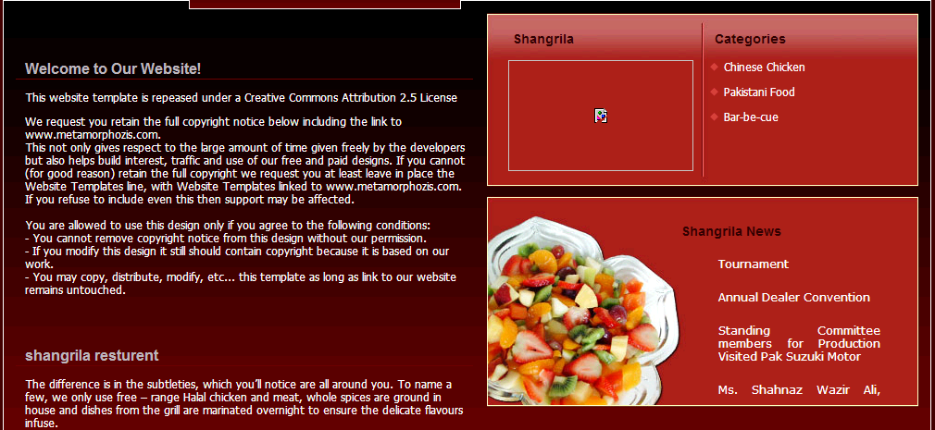

**44**

**Main page**

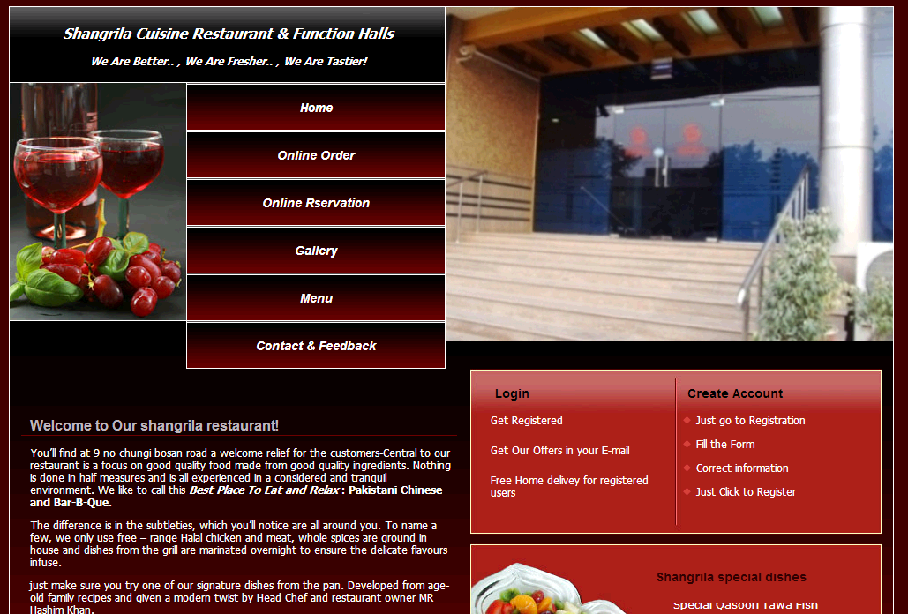

**45**

**Log in**

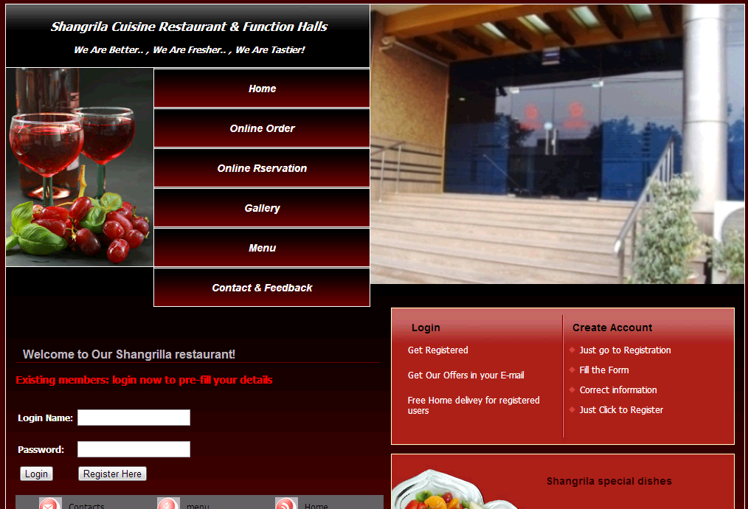

**46**

**Menus**

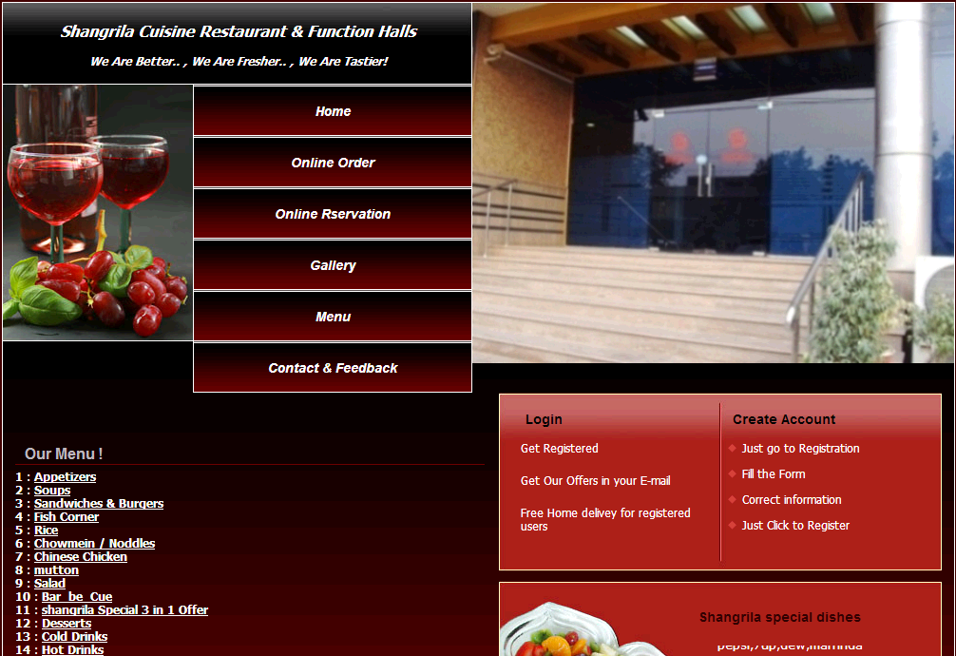

**47**

**Registration form**

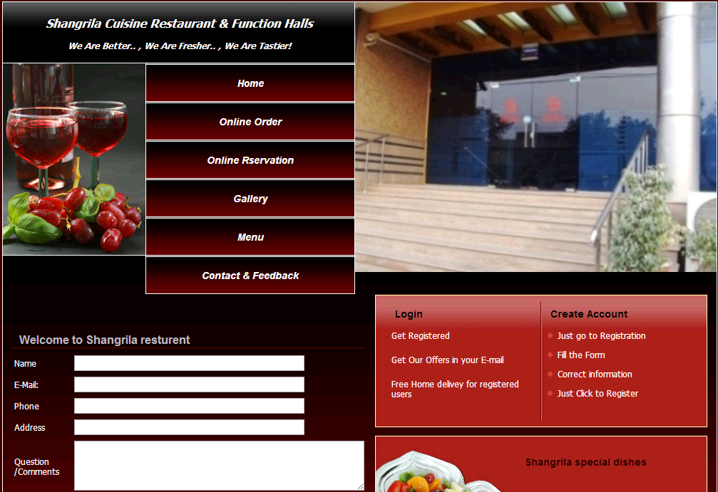

**48**

**Admin**

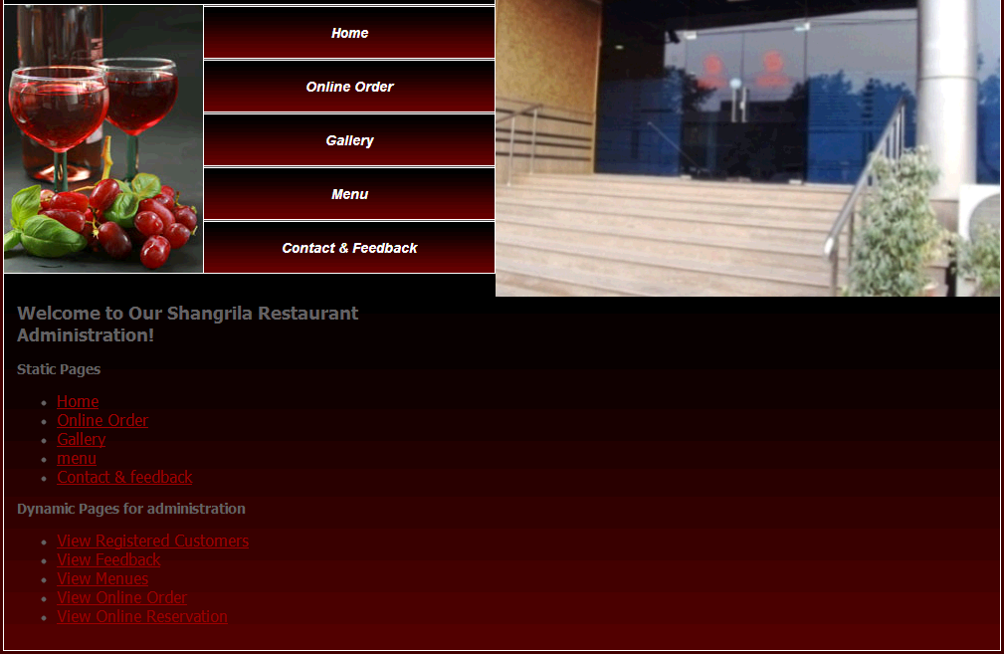

**49**

**Create Account**

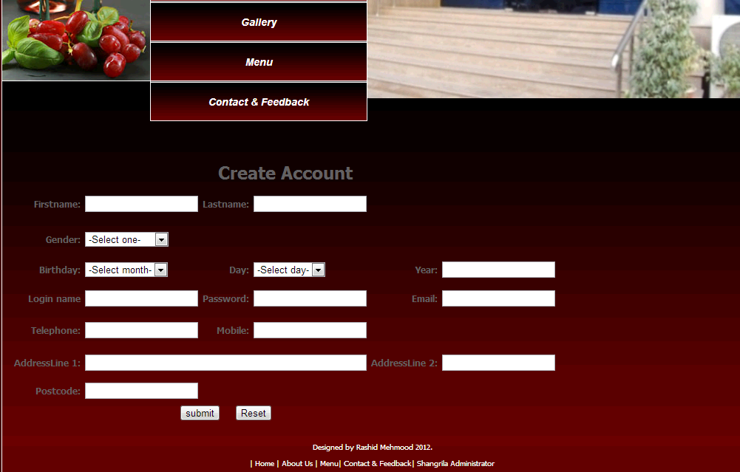

**50**

**References:**

[www.google.com](http://www.google.com)

[www.w3schools.com](http://www.w3schools.com)/php/default.asp

[www.php.net](http://www.php.net)

[www.itelam.com](http://www.itelam.com) › [IT Zone](http://www.google.com.pk/url?url=http://www.itelam.com/forumdisplay.php%3Ff%3D7&rct=j&sa=X&ei=yFOkUJDRGIXotQbk4ICoDA&ved=0CEUQ6QUoADAD&q=php+tutorial+in+urdu+pdf&usg=AFQjCNHkZjlhvEcRSLFRdOPCaSRu4vPZdw) ›

[www.youtube.com](http://www.youtube.com)

vusolutions.com/.../what-is-**php**-learn-**php**-mysql-in-**urdu**-language-e...

www.**wikipedia**.org/

Book:

PHP Development

**51**